Design and Implementation of DDR4 for high speed memory access in SOC

CONTENTS:
- INTRODUCTION 3
  - Overview: 3
  - Project Architecture: 3
  - Basics of DDR4: 4
  - MEMORY ORGANIZATION: 4
- FUNCTIONAL BLOCK DIAGRAM(x8) 9
- PROJECT BLOCK DIAGRAM 10
  - DDR Controller 10
Key Responsibilities: 10
  - DFI (DDR PHY Interface) 11
Key Responsibilities: 11
  - DDR4 Memory Module 11
Key Responsibilities: 11
- SIGNAL DESCRIPTION 12
  - DDR Controller Signals 12
  - DFI (DDR PHY Interface) Signals 13
  - DDR4 Memory Module Signals 14
- FUNCTIONAL BEHAVIOR 14
  - State Machine and Control Logic in DDR Controller 15
    - State Descriptions 15
    - FSM Logic in the Controller 15
  - DFI Interface and Signal Flow 15
  - Memory Addressing Mechanism in DDR 16
    - Address Breakdown 16
- MODE REGISTER CONFIGURATION 16
  - Mode Register Configuration Details 17
  - Burst Type and Length 17
- TIMING DIAGRAMS 18
- CONCLUSION 20
- REFERENCES 20
20

INTRODUCTION

Overview:
DDR (Double Data Rate) memory is a high-speed volatile memory widely used in computing and embedded systems for efficient data storage and retrieval. Unlike its predecessors, DDR4 offers improved speed, lower power consumption, and greater data bandwidth, making it an ideal choice for modern applications.
The custom DDR4 memory design described in this document is specifically tailored to meet the requirements of a specialized system, balancing performance, efficiency, and hardware constraints. The design integrates a DDR Controller, a DDR PHY (DFI interface), and the DDR4 memory module to facilitate seamless read and write operations. The interface and control signals ensure proper data transfer, address management, and command execution, forming a robust memory architecture.

Project Architecture:
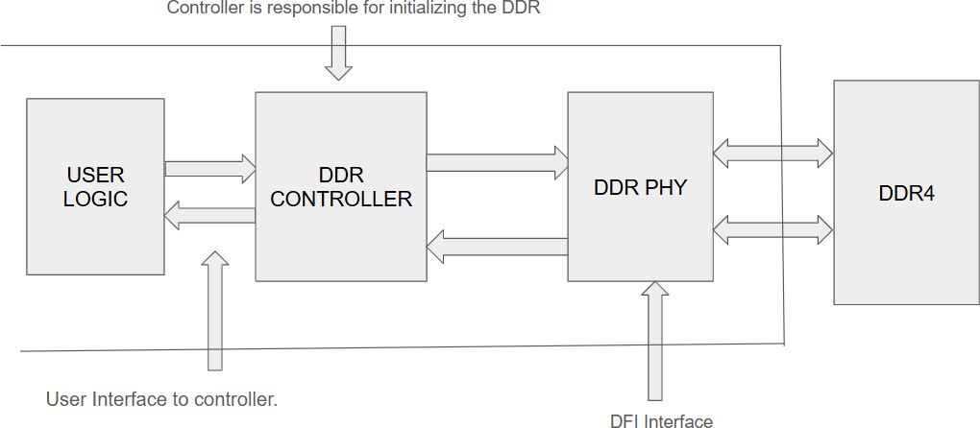
The custom DDR4 design is structured around three main components:

Fig1.1 Project architecture

    - DDR Controller: This module manages data flow between the processor and the memory, handling read/write requests, address decoding, and timing synchronization.
    - DDR PHY (DFI Interface): The DDR PHY, which follows the DFI (DDR PHY Interface) standard, acts as a bridge between the controller and the DDR4 memory, ensuring proper signal timing and electrical characteristics.
    - DDR4 Memory Module: The core memory unit where data is stored and retrieved based on read/write commands issued by the controller.
Note: Refer Fig 1.2

Basics of DDR4:
DDR4 (Double Data Rate 4) is the fourth generation of DDR memory, offering significant improvements over DDR3 in terms of speed, power efficiency, and density. The key advantages of DDR4 include:
- Higher Bandwidth: DDR4 operates at speeds ranging from 1600 MT/s to 3200 MT/s, with newer versions reaching even higher speeds.
- Lower Power Consumption: Operating at 1.2V (compared to DDR3’s 1.5V), DDR4 reduces power usage, making it more efficient.
- Increased Memory Density: DDR4 supports higher-capacity modules, enabling systems to accommodate more memory.
- Improved Signal Integrity: With better clocking mechanisms, DDR4 ensures reliable high-speed operation.
DDR4 memory uses a pipelined architecture that allows simultaneous processing of multiple commands. It employs the following key techniques:
    - Burst-Oriented Access: Data is accessed in fixed burst lengths (BL8 or BC4), ensuring efficient transfer.
    - Bank Grouping: Multiple banks are grouped to allow interleaved access, improving throughput.
    - Dual Data Rate (DDR) Clocking: Data is transferred on both rising and falling edges of the clock signal, doubling the effective bandwidth.
This document outlines the key aspects of a custom DDR4 memory design, detailing its architecture, interface, and fundamental DDR4 operations. The block diagram provides a clear representation of the design components and their interactions, highlighting the integration of the DDR Controller, DDR PHY, and DDR4 memory module. Understanding the underlying principles of DDR4, including its burst access, and timing constraints, is essential for optimizing performance and ensuring efficient memory utilization.
In the following sections, detailed specifications and timing diagrams will be provided to further elaborate on the design requirements and functionality of this custom DDR4 system.

MEMORY ORGANIZATION:
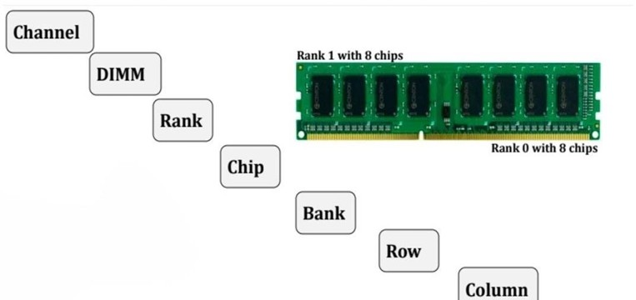

Fig 1.2 Memory hierarchy

Channel
A channel is the communication path between the memory controller (typically located within the CPU or chipset) and the DIMM (Dual Inline Memory Module). DDR4 supports 2 or 4 channels in most configurations, allowing simultaneous data transfers across multiple channels.
Purpose: Channels enable parallel data access and improve the overall bandwidth.

Advantages: Multi-channel configurations (like dual-channel or quad-channel) increase memory throughput, benefiting applications such as gaming, video editing, and scientific simulations.

DIMM

(Dual Inline Memory Module) A DIMM is the physical circuit board that houses multiple DRAM (Dynamic Random Access Memory) chips. DDR4 DIMMs typically have a 64-bit data bus, though 72 bits are used in modules with ECC (Error-Correcting Code).
Types: Common DDR4 DIMMs include UDIMM (Unbuffered DIMM) for desktops and RDIMM (Registered DIMM) for servers.
Scalability: DIMMs can host higher-capacity DRAM chips, supporting up to 64GB per module in standard configurations and even higher in specialized setups.
Key Features: Enhanced signal integrity and power efficiency compared to previous DDR generations.

Rank

A rank represents a group of DRAM chips on a DIMM that operate simultaneously. A DIMM can have 1, 2, or 4 ranks, depending on its design.
Function: Ranks allow the memory controller to access different subsets of DRAM chips, improving parallelism and throughput.
Performance: Multiple ranks can improve performance by enabling rank interleaving, where the controller alternates between ranks to mask access latencies.
Configuration: Each rank typically consists of 8 or 16 DRAM chips, depending on the memory's bit-width and capacity.
Memory rank: Memory rank is a term that is used to describe how many sets of DRAM chips, or devices, exist on a memory module. A set of DDR4 DRAM chips is always 64-bit wide, or 72-bit wide if ECC is supported. Within a memory rank, all chips share the address, command and control signals.
The concept of memory rank is very similar to memory bank. Memory rank is a term used to describe memory modules, which are small printed circuit boards with memory chips and other electronic components on them; and memory bank is a term used to describe memory integrated circuit chips, which are the building blocks of the memory modules.
A single-rank (1R) memory module contains one set of DRAM chips. Each set of DRAM chips is 64-bits wide, or 72-bits wide if Error Correction Code (ECC) is supported.
A dual-rank (2R) memory module is similar to having two single-rank memory modules. It contains two sets of DRAM chips, therefore doubling the capacity of a single-rank module. The two ranks are selected one at a time through a chip select signal, therefore only one rank is accessible at a time.
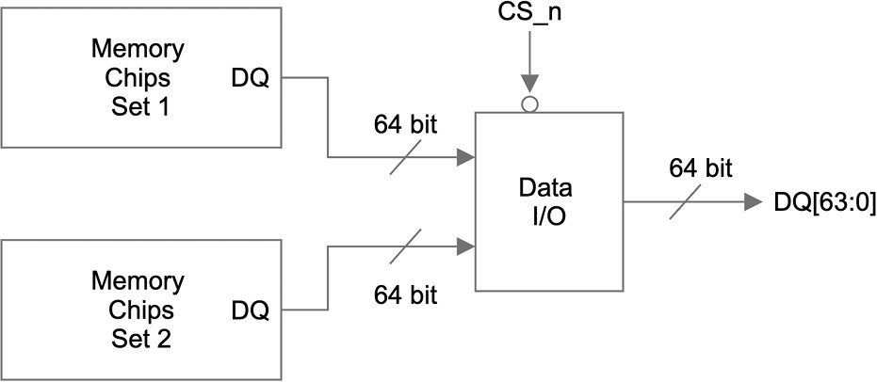
Likewise, a quad-rank (4R) memory module contains four sets of DRAM chips. It is similar to having two dual-rank memories on one module, and it provides the greatest capacity. There are two chip select signals needed to access one of the four ranks. Again, only one rank is accessible at a time.

Fig 1.3 DQ Signal flow

Figure 1.3 is a simplified view of the DQ signal flow on a dual-rank memory module. There are two identical sets of memory chips: set 1 and set 2. The 64-bit data I/O signals of each memory set are connected to a data I/O module. A single bit chip select (CS_n) signal controls which set of memory chips is accessed and the data I/O signals of the selected set will be connected to the DQ pins of the memory module.
Dual-rank and quad-rank memory modules double or quadruple the memory capacity on a module, within the existing memory technology. Even though only one rank can be accessed at a time, the other ranks are not sitting idle.

Chip

A memory chip (or IC) is the basic building block of the DIMM, consisting of numerous memory cells organized into banks. Each chip handles specific portions of the addressable memory space. Structure: DDR4 chips are built with 16 banks per chip, organized into 4 bank groups (discussed below) for efficient access.
Size and Density: With advances in fabrication, DDR4 chips support higher densities, enabling capacities of 4Gb to 16Gb per chip.
Memory module capacity: The capacity of each memory chip, or device, is defined as memory depth x memory width. Memory width refers to the width of the data bus, i.e. the number of DQ lines of each memory chip.
The width of memory chips are standard, they are either x4, x8 or x16. From here, we can calculate how many memory chips are in a 64-bit wide single rank memory. For example, with x4 memory chips, we will need 16 pieces (64 ÷ 4 = 16); and with x8 memory chips, we will only need 8 of them. Let's look at the following two high-level block diagrams of 1Gbx8 and 2Gbx4 memory chips.
The total memory capacity for both of them is 8Gb. Figure 2 describes the 1Gb x8 configuration, and Figure 3 describes the 2Gbx4 configuration. With DDR4, both x4 and x8 devices have 4 groups of 4 banks. x16 devices have 2 groups of 4 banks.
The capacity, or density of a memory chip is calculated as:

Memory Depth = Number of Rows * Number of Columns * Number of Banks Total Memory Capacity = Memory Depth * Memory Width
In the example of a 1Gbx8 device as shown in Figure 2 above:

Number of Row Address Bits = 16

Total Number of Rows = 2 ^ 16 = 65536 Number of Column Address Bits = 10 Total Number of Columns = 2 ^ 10 = 1024 And the calculation goes:
Memory Depth = 65536 Rows * 1024 Columns * 16 Banks = 1Gb Total Memory Capacity = 1Gb * 8 = 8Gb.

Bank

A bank is a subset of memory cells within a chip, arranged in a grid of rows and columns. DDR4 typically uses a 16-bank architecture, divided into 4 bank groups for better parallelism.
Parallelism: Multiple banks allow the memory controller to access different parts of the chip simultaneously, improving throughput.
Bank Grouping: Banks are grouped to reduce latency when switching between them, as each group can process commands independently.
- Row A row refers to a horizontal group of memory cells within a bank. Rows are activated together during read or write operations.
Activation: When a row is activated, its data is loaded into the row buffer for access. Capacity: Each row holds thousands of bits, depending on the chip's architecture.
Significance: Activating a row consumes power, so DDR4 optimizes row activation to balance speed and energy efficiency.
- Column A column is a vertical group of memory cells within an active row. Columns are accessed after the row is activated, enabling precise reading or writing of data.
Accessing Data :Column access occurs when the memory controller issues a column address strobe (CAS) signal.
Precision: This structure allows DDR4 to efficiently access specific bits of data stored in large arrays.

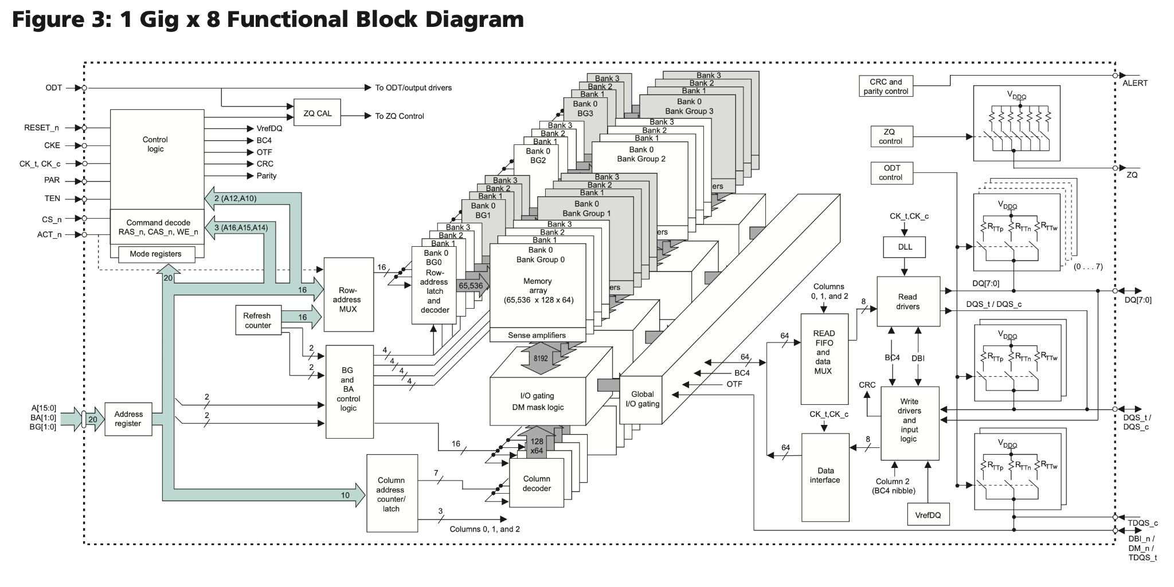
FUNCTIONAL BLOCK DIAGRAM(x8)

Fig 2.1 Functional block diagram NOTE: IT IS A REFERENCE BLOCK DIAGRAM
- DDR4 SDRAM is a high-speed, CMOS dynamic random access memory. It is internally configured as an 16-bank (4-banks per Bank Group) DRAM.
- DDR4 has an internal structure of having banks in bank groups. If you have DDR3, you don’t have bank groups, you just have banks. In the DDR4 x4 memory chip, it has 4 bank groups and in each bank group you have 4 banks, which means 4 sets of DDR3 shoved into one memory chip.

Summary of Workflow:

  - Initialization: Configure mode registers.
  - Command Reception: Decode commands and address inputs.
  - Row Activation: Activate the desired row in the selected bank.
  - Column Selection: Access the specific column for the operation.
  - Data Transfer: Read or write data.
  - Refresh: Periodic automatic refresh of memory cells.
This process ensures the DDR4 chip can operate at high speed, handle large memory capacities, and maintain data integrity while being compatible with the requirements of modern computing systems.

PROJECT BLOCK DIAGRAM

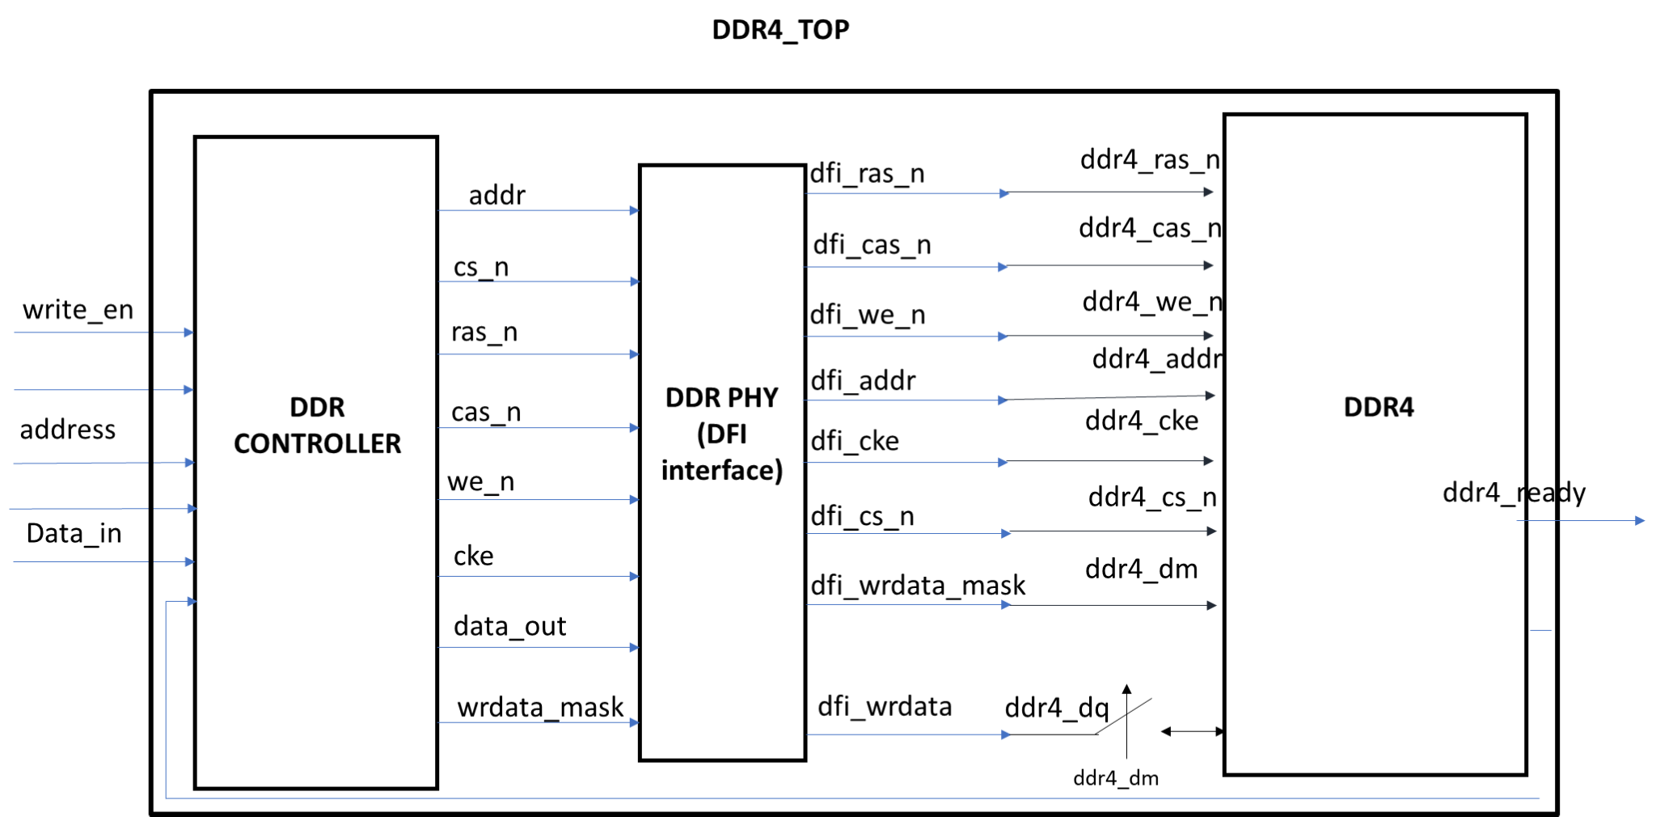
Fig 3.1 Block diagram of Project

DDR Controller

The DDR Controller is the central block that manages communication between the system and the DDR4 memory module. It processes read and write requests from the system, translates them into DDR4-compatible commands, and ensures data integrity during transfers.
Key Responsibilities:

    - Command Handling: Interprets system requests (read_en, write_en, address, data_in) and generates DDR4 signals (cs_n, ras_n, cas_n, we_n).
    - Data Flow Management: Controls the movement of data between the processor and memory.
    - Memory Access Coordination: Ensures that memory is accessed efficiently while avoiding conflicts.
This block acts as the brain of the memory system, ensuring smooth and efficient interaction between the processor and the DDR4 module.

DFI (DDR PHY Interface)
The DFI Interface is responsible for establishing a reliable communication link between the DDR Controller and the DDR4 Memory Module. It adheres to the DDR PHY Interface (DFI) standard, which standardizes interactions between the controller and the memory's physical layer.
Key Responsibilities:

    - Signal Translation: Converts the high-level memory commands from the controller into physical DDR4 signals.
    - Clocking & Synchronization: Ensures that all read and write operations align correctly with the memory clock.
    - Read/Write Data Handling: Uses dfi_wrdata and dfi_wrdata_mask for data transmission.
    - On-Die Termination (ODT) Control: Manages termination settings for signal integrity and reduced power consumption.
This block ensures efficient data transfers between the controller and DDR4 memory while maintaining signal integrity.

DDR4 Memory Module
The DDR4 Memory Module is the actual storage unit where data is read from and written to. It consists of multiple memory banks, each capable of independent operations, allowing for parallel access and higher throughput.
Key Responsibilities:

    - Data Storage: Stores and retrieves data based on commands from the DDR Controller.
    - Address Decoding: Uses ddr4_addr and bank_sel to locate the correct memory location.
    - Command Execution: Operates based on ddr4_ras_n, ddr4_cas_n, and ddr4_we_n signals to perform read, write, and activate operations.
    - Data Bus Communication: Uses ddr4_dq to transfer data in and out of memory during read and write cycles.
This block is the core storage unit of the system, responsible for handling data with high efficiency and speed.

​SIGNAL DESCRIPTION

DDR Controller Signals

Signal Name | Size (bit) | Directio n | Description
clk | 1 | Input | System clock signal for synchronization.
rst_n | 1 | Input | Active-low reset signal to initialize the controller.
read_en | 1 | Input | Read enable signal; initiates a read operation when high.
write_en | 1 | Input | Write enable signal; initiates a write operation when high.
address | 32 | Input | Address bus for memory access.
data_in | 16 | Input | Data bus carrying information to be written to memory.
clk_enable | 1 | Input | It enables the clk
data_out | 16 | Output | Data bus carrying information read from memory.
addr | 32 | Output | Takes the output address that need to be given to ddr
cs_n | 1 | Output | Chip Select (Active low); enables the memory module.
ras_n | 1 | Output | Row Address Strobe (Active low); activates a specific row in memory.
cas_n | 1 | Output | Column Address Strobe (Active low); selects the column in memory.
we_n | 1 | Output | Write Enable (Active low); indicates a write operation.
cke | 1 | Output | It enables the clk
wrdata_mask | 1 | Output | Enables writing

DFI (DDR PHY Interface) Signals

Signal Name | Size (bit) | Directio n | Description
dfi_addr | 32 | Output | Address for memory transactions.
dfi_wrdata_mask | 1 | Output | Enable writing
dfi_wrdata | 16 | Output | Data written to DDR4 memory.
dfi_cs_n | 1 | Output | Chip Select signal for memory module.
dfi_ras_n | 1 | Output | Row Address Strobe signal.
dfi_cas_n | 1 | Output | Column Address Strobe signal.
dfi_we_n | 1 | Output | Write Enable signal.
dfi_cke | 1 | Output | Clock enabling

DDR4 Memory Module Signals

Signal Name | Size (bit) | Direction | Description
ddr4_clk | 1 | Input | Clock signal for DDR4 operations.
ddr4_reset | 1 | Input | Active-low reset signal for DDR4 memory.
ddr4_addr | 32 | Input | Address bus to select memory locations.
ddr4_dq | 8 | In/Out | Data bus for read and write operations.
ddr4_ras_n | 1 | Input | Row Address Strobe to select rows.
ddr4_cas_n | 1 | Input | Column Address Strobe to select columns.
ddr4_we_n | 1 | Input | Write Enable signal.
ddr4_cke | 1 | Input | Enable clk
ddr4_dm | 1 | Input | Enable writing
ddr4_cs_n | 1 | Input | Chip Select to enable memory access.

FUNCTIONAL BEHAVIOR
The DDR memory controller is responsible for managing the interface between the processor and the DDR memory. It generates the required control signals (RAS, CAS, CS, WE) based on a finite state machine (FSM) logic. These signals are then passed through the DFI interface to the DDR memory module. The controller ensures proper sequencing of commands for memory access, addressing, and data transfer.

State Machine and Control Logic in DDR Controller
The DDR memory controller operates based on a finite state machine (FSM), which dictates the transitions between different memory access states. The primary states are:

State Descriptions

State | Description
IDLE | Initial state of the controller.
ACTIVATE | A row is activated based on the incoming address.
READ | The memory fetches data from the active row.
WRITE | Data is written to the active row.
PRECHARGE | The active row is closed, returning the memory to the IDLE state.

FSM Logic in the Controller
The state transitions occur as follows:

      - The controller starts in the IDLE state and waits for a memory request.
      - When an address is received, the ACTIVATE state is triggered, enabling the correct row for access.
      - If a read request is made, the system moves to the READ state; for a write request, it transitions to the WRITE state.
      - Once read/write operations are complete, the system enters the PRECHARGE state, closing the active row.
      - Finally, the system transitions back to IDLE, ready for the next command.

DFI Interface and Signal Flow
The generated control signals (RAS, CAS, CS, WE) are forwarded to the DFI (DDR PHY Interface), which serves as an intermediate communication layer between the controller and the DDR memory module. The DFI interface processes these signals and forwards them to the DDR memory module for execution.

Memory Addressing Mechanism in DDR
Inside the DDR memory module, the provided address is divided into three parts:

Address Breakdown

State | Address Mapping
ACTIVATE | Extracts row address from the input address.
MRS (Mode Register Set) | Configures mode registers based on address bits.
READ/WRITE | Extracts column address from the input address.
PRECHARGE | Closes the row and returns to IDLE.

​MODE REGISTER CONFIGURATION
Note: The scope of this project is limited to implementation of only one Mode register(MR0). MR1 to MR7 implementation can be extended in the future.
During the MRS (Mode Register Set) state, address bits configure the DDR mode registers. These registers store configurations like burst length, CAS latency, and burst type.

Mode Register Configuration Details
The following address bits are used to configure the mode register: cas_RD_latency <= ddr4_addr[7:3];
burst_type <= ddr4_addr[2]; burst_len <= ddr4_addr[1:0];
- CAS Read Latency (cas_RD_latency): Extracted from bits [7:3] of the address.
- Burst Type (burst_type):
  - 0: Sequential Burst.
  - 1: Nibble Burst.
- Burst Length (burst_len):
  - 01: Burst of 8
  - 00: Burst of 4

Burst Type and Length

Burst Type Bit (burst_type) | Operation
0 (Sequential) | Data is fetched in a continuous sequence.
1 (Interleaved) | Data is fetched in a nibble order.

Burst Length (burst_len) | Operation
01 | Burst of 8 transfers.
00 | Burst of 4 transfers

TIMING DIAGRAMS

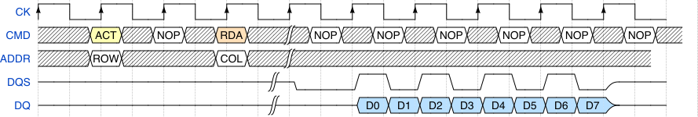
Fig.7.1.Read operation based on burst oriented(BL8)

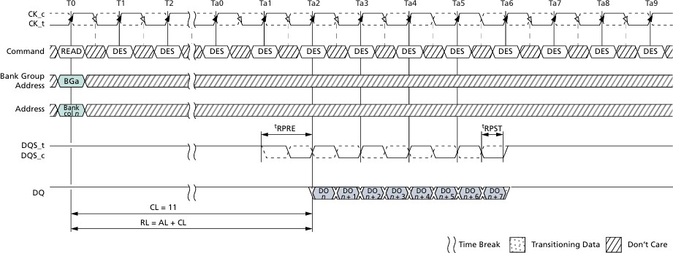
- The clock cycles are labeled as T0, T1, T2, and so on, showing the sequential operation of the DDR memory.
- The command row shows the issued command. In this case, a READ command is issued at T0.
- The subsequent cycles are marked as "DES" (Don't Care or Deselected), indicating that the command bus is idle after the READ command.
- The Bank Group Address (BGa) and Bank Address (Bank col n) define the target memory location for the READ operation.
- The row and column addresses are provided to specify the exact memory location to be accessed.
- These signals represent the Data Strobe (DQS), which is used to synchronize the data transfer.
- The DQS signal is initially idle and starts toggling when data is ready to be transferred.
- The DQ line represents the actual data being transferred from the memory to the controller.
- The data transfer begins after the Read Latency (RL = AL + CL), where AL is the Additive Latency and CL is the CAS Latency.
- The data bursts (DO, D1, D2, etc.) occur in synchronization with the DQS signal.

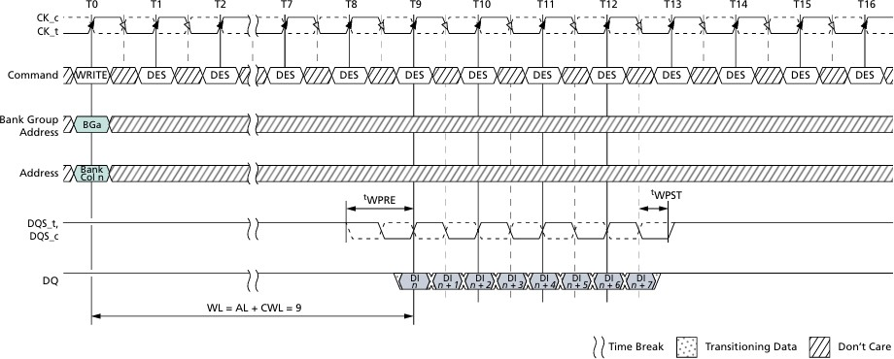
Fig.7.2.Write operation based on the burst oriented(BL8)
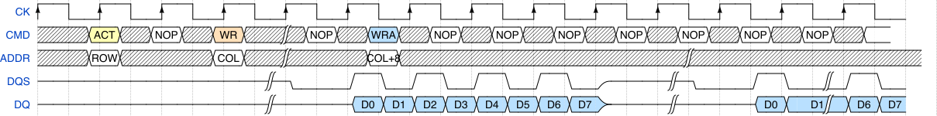

- These signals represent the differential clock signals used to synchronize DDR memory operations.
- The timeline is divided into clock cycles labeled as T0, T1, T2, and so on.
- A WRITE command is issued at T0, indicating the start of a write operation.
- After the WRITE command, the command bus enters a don't care (DES - Deselected) state.
- Bank Group Address (BGa) and Bank Address (Bank Col. n) specify the target memory bank and column where data will be written.
- The memory controller selects the appropriate bank and column for the operation.
- The Data Strobe (DQS) signals synchronize the data transfer.
- The DQ line represents the actual data being transferred from the controller to the memory.
- The data write begins after the Write Latency (WL = AL + CWL = 9).
- Time Break: A visual break in the timeline for readability.
- Transitioning Data: Indicated by a dotted pattern, showing active transitions.
- Don’t Care (DES): Represented by diagonal hatching, meaning values are not significant in those cycles.

CONCLUSION
- The controller generates RAS, CAS, CS, and WE based on FSM logic.
- These signals are forwarded to the DFI interface, which relays them to the DDR memory.
- The DDR memory module extracts row and column addresses in different states.
- During MRS state, mode registers configure burst length, CAS latency, and burst type.
- The FSM ensures proper sequencing between IDLE, ACTIVATE, READ, WRITE, and PRECHARGE states.

​REFERENCES

- https://www.systemverilog.io/design/ddr4-basics/
- https://www.mouser.com/datasheet/2/671/8gb_ddr4_sdram-3178010.pdf

